Renju lesson on March 15, 2001

Hello all! Welcome to Online Renju Class. Today we have the first lesson in new Playsite. I am sure it is very good for us. :)
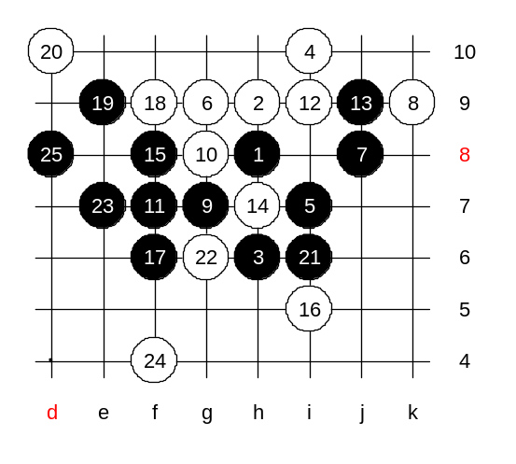
Today we will begin with d11 opening. It is one of the most popular openings. About 5 years ago, this opening was considered to be white big advantage. In 1997, it turned to be black advantage. In 1999, some people considered this opening to be almost black win. Now, in 2001, several new ideas were found for white, and the outcome is unclear – it is hard to tell whether d11 opening is good for black or white.
Actually, there is only one 4th move that common for d11 opening. Other 4th moves lead to other openings – i10. As a tradition, we will first demonstrate the main 5th move, just for the record. The black win is quite easy. 5-i7. There are two 6th moves – 6-g9 and 6-i9, others are too weak. By the 11th move black gets winning position.
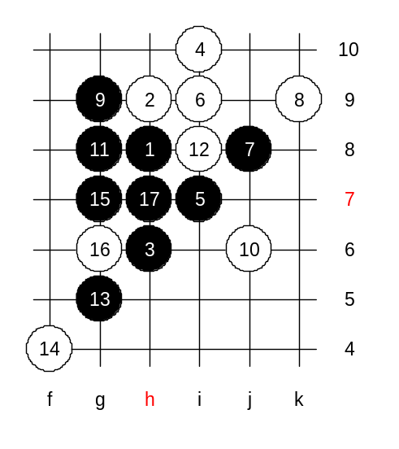

Lets test another 6th move, too.
Here the black win is easy, too.

Now we will learn about other 5th moves.
First of all, let me remind you, 5th moves to points g9, g8, g7, g6 lose fast, and we will not study them. We will study some difficult 5th moves. There are three moves that get some attention. We begin with 5-f8. Some words about it first. In old Japanese theory, the move was quite popular. However, their analysis is somewhat imperfect. I found a serious bug in one of their books. Let me show you the beginning of standard theory here. 6-i9. Not that i9 is the only possible move here. These 15 moves are

traditional theory. From 16th move there are two different ways – old style and new style. Lets check the old style first and I will show you the bug that Japanese book has. The position looks very strong for white, especially after the 22nd move. Black defends with the only possible moves.
There are 28 stones on board. This is the theory from Japanese renju book. They think white wins, but actually black has win here. 29-i5!
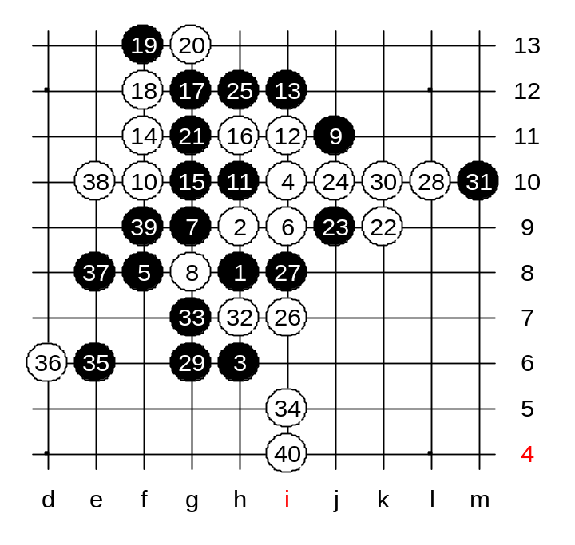

Now, we try a better 28th move, to L10. It is much better move, however, black can defend here. You suggest 29-g6. Alright, we test it.
There are 40 moves on the board. This is your medium level homework. Please find black win.

This is the advanced level homework. This 5th move is losing. Please find white win starting from 10th move.
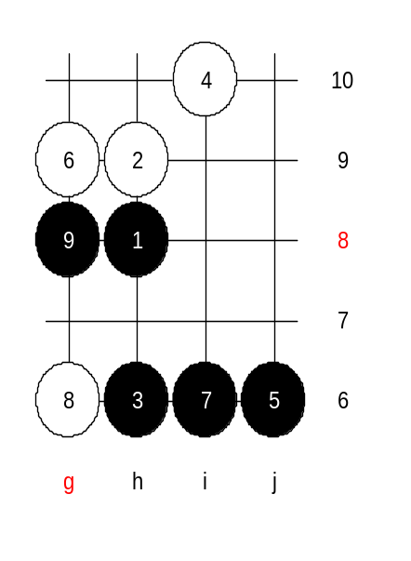
The class is over now. Thank you for your active participation and see you next week!

